In Like A Lion,
Out Like A Lamb

Thank you for your interest in volunteering at our shelter.
Located in Stanmore Bay, Auckland, this 80sqm communal enclosure has taken years of fundraising and hard work to build. Initially planned to be one room, we have added section by section as we have been able to, and it currently sits across 7 levels.

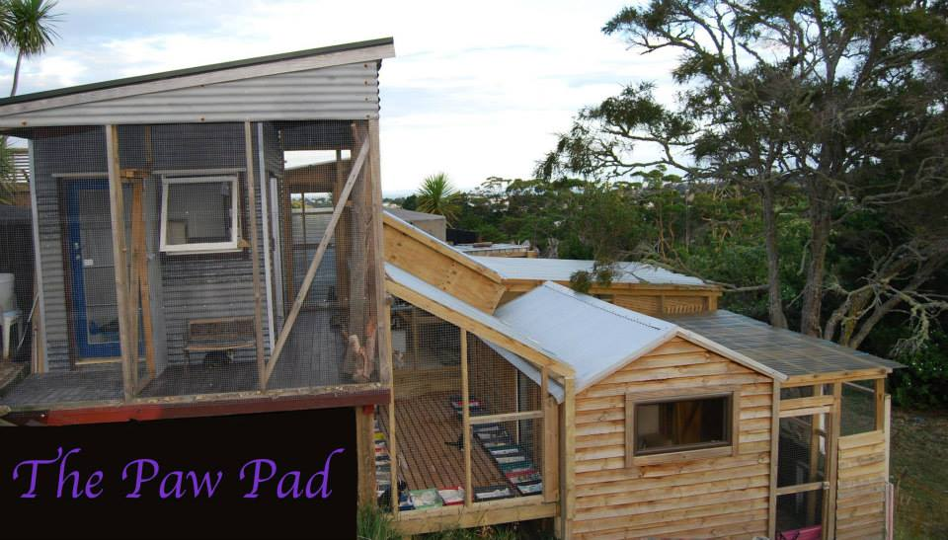

The Paw Pad was created to enable placement of unsocialised adult rescues straight off the streets to allow them space and freedom, but also enable taming. These rescues have either forgotten how to interact with humans, or have never experienced a human to feline bond. Once settled and trusting of humans, they are moved into foster homes, to prepare them to find their forever homes.

We rely entirely on volunteers to help us with all aspects of what we do – one of those volunteer positions is within The Paw Pad.

Duties include changing litter boxes (note – we are usually at maximum capacity which means there can be up to 35-40 litter boxes to change), filling food and water, checking for “toileting accidents”, spot cleaning, general cleaning, and interacting with our rescues.

We have an R18 policy on The Paw Pad only due to the nature of the cats we work with. We have many volunteers from 14 years and upwards who have shown maturity beyond their years, and we have welcomed them with open arms to volunteer in our shelter. So if you are under 18, but passionate, reliable, trustworthy and dedicated, please apply.

Shifts are morning or afternoon, and usually take around 1 hour to complete. Any extra time you can put in to help with cleaning, maintenance, or socialising is hugely appreciated. If you or someone you know is a bit of a handy man, we are always adding enrichment to the shelter, and are always needing help with building of ramps etc so please let Danielle know if you or someone you know can help in this area.

Turning up to your shift is extremely important. If our volunteers pull a no-show, our rescues suffer. We understand life throws curveballs into every day, but we appreciate notice as early as possible for any volunteers who cannot make their shift. If it is just that you will be a bit later, that is not problem at all, but if you will not be turning up at all, we must be notified. You can text Danielle 021-157-1575 (first and best option) or email danielle@gutterkitties.co.nz (I don’t always check this throughout the day).

Our rescues are in varying stages of their rehabilitation – some we do not recommend approaching at all, some, given time to learn you, will seek out your lap if given the chance. Once our rescues are “socialised” we then seek a suitable foster home to help take them on the next step of their journey learning to be a “house cat”. If at any stage you decide you may like to foster one of our shelter cats (or any of our incoming cat and kitten rescues) please email tracey@gutterkitties.co.nz who will assist you.

Each rescue in our shelter costs us on average $15 per week, this does not include cleaning products or shelter upkeep, and with an average of 25-30 residents at any one time, our expenses are huge. If you would like to help with fundraising either at your place of work, with family and friends, or other areas, please let Danielle know.

If you are wanting to help at our shelter, please fill in the application form and either email it to danielle@gutterkitties.co.nz, or drop it into our Op Shop at Unit 9, 667 Whangaparaoa Road, Stanmore Bay (behind The Crows Nest). We are always needing volunteers here too.

Todays Date:
PERSONAL DETAILS
Preferred Name: |  |  |  | Full Name:
Title: | Mr Mrs Miss Ms Dr |  |  | Are you over 18 years old? |  |  |  | Yes No
Address:
Home Phone: |  |  |  | E-mail:
Mobile Phone: |  |  |  | Date of Birth: |  |  | (optional)
As part of the recruitment procedure we may collect and store sensitive personal data about you. We are required by law to obtain your consent to such data being recorded. It is our policy to store data relating to recruitment procedures for a minimum of 12 months after the date on which it is submitted. Any information of this nature will be treated confidentially.

Gutter Kitties abides by the provisions of the Privacy Act 1993 in its dealings with volunteers. Information on this form will not be used in any way that you would not reasonably expect, nor disclosed to a third party without your consent.
TRANSPORT
Do you have a current drivers’ license? |  |  | Yes No
SKILLS / EXPERIENCE / WORK HISTORY
Please tell us why you want to volunteer with Gutter Kitties and what you hope to get from your experience with us. This can include any relevant voluntary or paid experience, any qualifications, hobbies or interests that you have had that would help you undertake the role that you are applying for.
MEDICAL HISTORY
Do you have any on going medical conditions that may be aggravated by working in this environment?  e.g. physical ailments, allergies, stress related, RSI |  |  |  |  | Yes No Unsure (if yes or unsure, please explain)

CRIMINAL HISTORY
Have you ever been convicted of a criminal offence? |  |  |  |  |  |  |  |  | Yes No Unsure
Are you awaiting the hearing of charges in a civil or criminal court of law? |  |  |  |  |  |  |  |  | Yes No Unsure
If you answered Yes or Unsure to either question above, please explain further
Are you happy for us to proceed with a criminal check if required? |  |  |  |  |  |  |  |  | Yes No
EMERGENCY CONTACT (NEXT OF KIN)
Contact Name: |  |  |  |  | Contact Number:
Your relationship: |  |  |  |  | 2nd Contact Number:
WORK / PERSONAL REFEREES
REFEREE 1 |  |  |  |  | Company Name:
Referee Name: |  |  |  |  | Referee Contact details:
Referee Position: |  |  |  |  | Your Position:
CONSENT AND DECLARATION
I, |  |  |  |  |  | (print full name)
declare that to the best of my knowledge the information provided in this application and in any resume enclosed is accurate and I understand that if any false or misleading information is given, or any material fact suppressed, my application will not be accepted, or if already accepted, my volunteer role will be terminated.

I further understand that any offer of a volunteer role, if made, is conditional upon satisfactory confirmation from the New Zealand Police of any criminal record.
Signed: |  |  |  |  |  |  |  | Date:
Thank you for taking the time to complete this application form. We will advise whether your application has been successful or not as soon as we can. If you have any questions please do not hesitate to contact us.
RETURNING THIS APPLICATION FORM
Email: |  | danielle@gutterkitties.co.nz |  |  | In Person: |  | Unit 9, 667 Whangaparaoa Road, Stanmore Bay

